***Rotating an object using player input***

**Objective:**

To create a script that allows a game object to rotate left or right when the player presses specific keys (left arrow and right arrow)

1. Start by opening unity and creating a new 3D Project

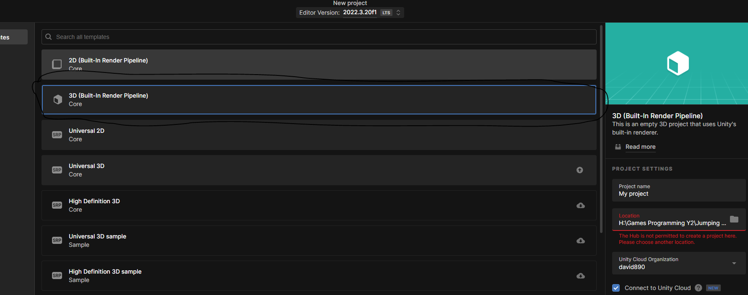

1. Go to the top menu and click Game Object then go to 3D Object and lastly pick a Cube.

Name the cube "Rotating Object" in the Hierarchy.

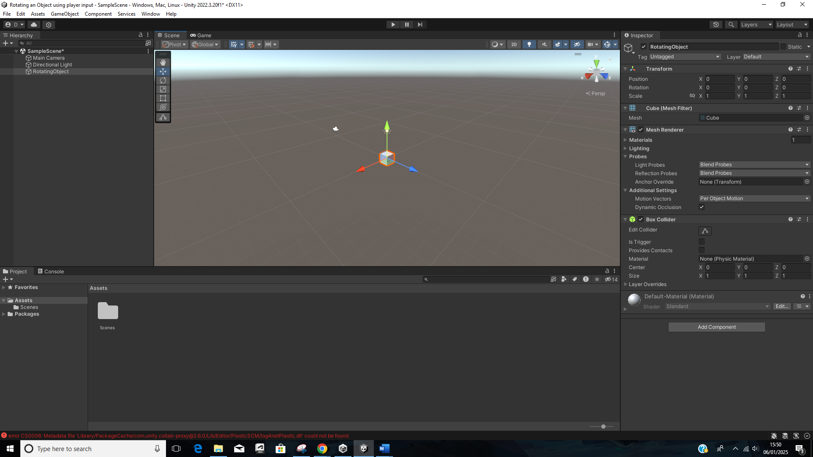

1. In the assets Folder, right click and select Create C# script and name the script ObjectRotation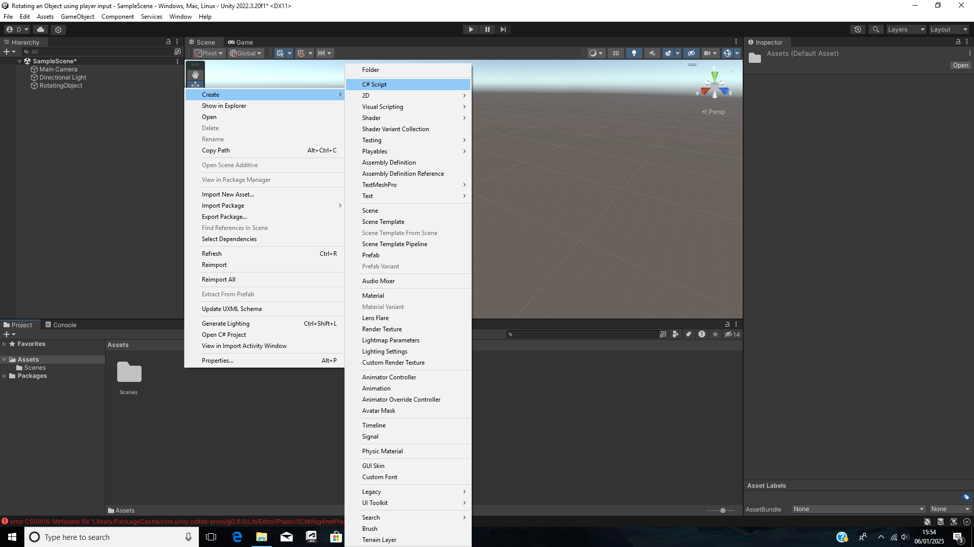
2. **Script explanation**

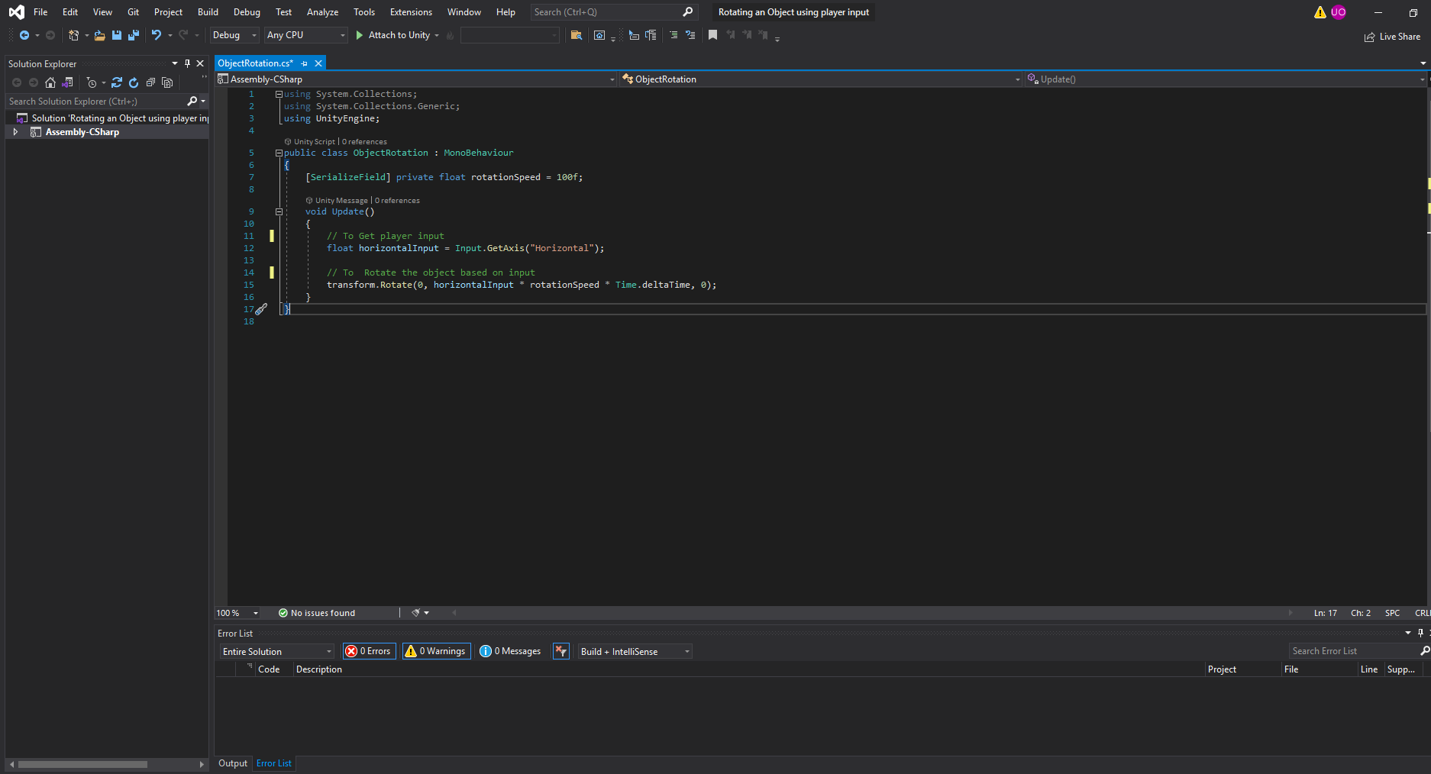

* **using System.Collections; using System.Collections.Generic;** using UnityEngine; This is the standard unity libraries for handing game objects and player input.
* **public class ObjectRotation : MonoBehaviour** The class name matches the script name and is derived from Monobehaviour.
* [**SerializeField] private float rotationSpeed = 100f;** [Serializefield] allows you to adjust the rotationspeed value in the unity inspector. rotationSpeed controls how fast the object rotates.
* **Input.GetAxis(“Horizontal”)** detects left or right input from the player (left/right arrow keys or A/D)
* **Transform.Rotate** rotates the object. The parameters (x,y,z) specify rotation along each axis. For example, x No rotation on the x-axis (Set to 0). Then for the y axis rotates based on the player input and for the z axis no rotation (also set to 0).
* **rotationSpeed *Time.deltaTime** ensures the rotation speed is frame-rate independent.

**Conclusion**

1. Save the script in your code editor.
2. Go back to unity and press play
3. Use the left arrow or A key to rotate left, and the right arrow or D key to rotate right and it should all work.